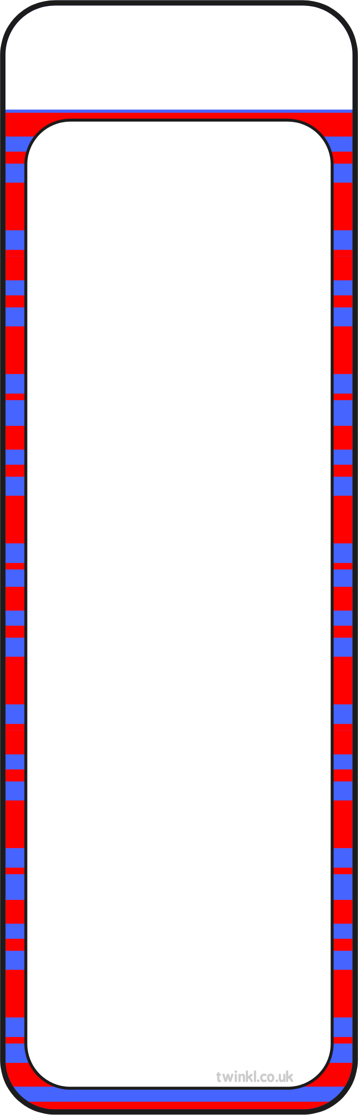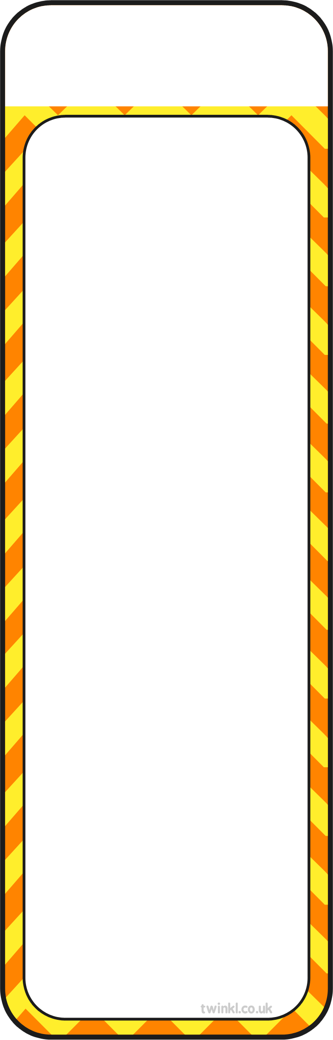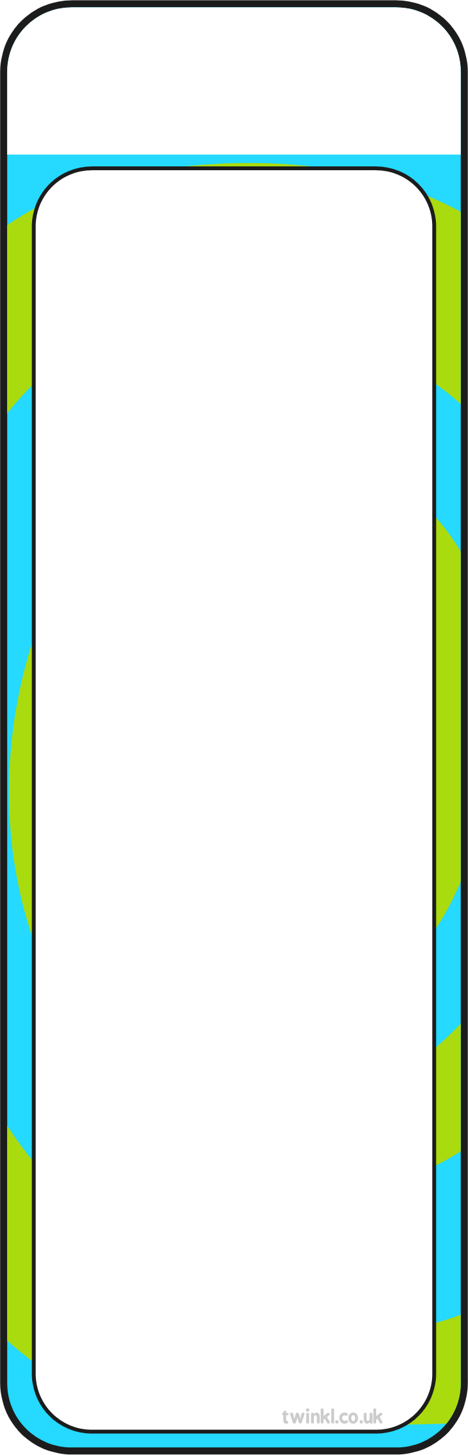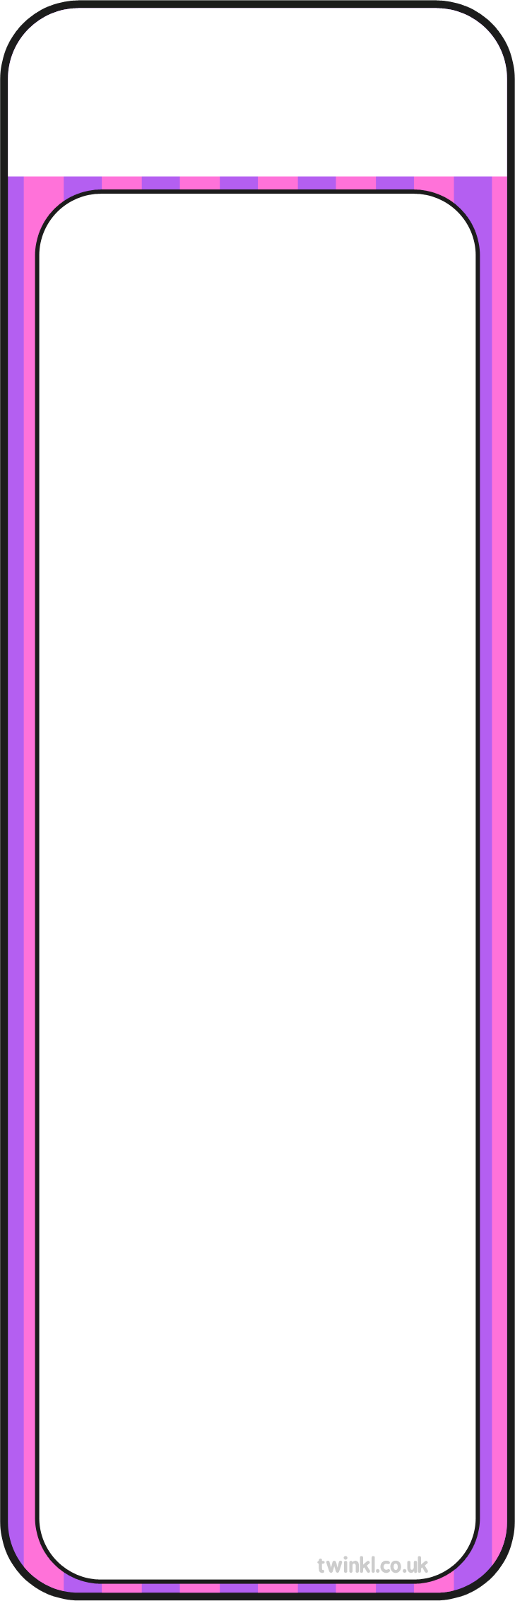

**If you can’t read a word, say:**

* Can you break it up?
* Are there any sounds you know?
* Do you know a word that looks like it?
* What could it say?
* Does the picture help?
* Do you recongise any words within it?
* Read to the end of the sentence and think about what words that might fit.

**Sequencing questions**

* What happens in the beginning of the story?
* How/where does the story start?
* What happened at the end of the…?
* Can you re-tell the story to me in 20 words or less?
* What happened before that?

**Vocabulary Questions**

* Can you find a word/sentence that tells/shows you that…
* Why do you think that the author used the word… to describe…?
* Can you find a word in the text that means the same as…?
* Find an adjective in the text.

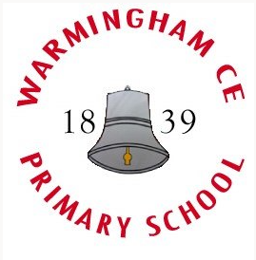

**Inference Questions**

* What do you think…means? Why do you think that?
* Why do you think…?
* How do you think…?
* When do you think…?
* Where do you think…?
* How has the author made us think that…?

**Retrieval Questions**

* Who is/are the main character(s)?
* When/where is the story set?
* Which is your favourite/worst/ funniest/scariest part of the story? Why?
* Tell me three facts you have learnt from the text.
* Find the part where…

**Prediction questions**

* Where do you think… will go next?
* What do you think…will say/do next?
* What do you think this book will be about and why?
* What do you think will happen in this chapter?
* How do you think this will end?
* Who do you think has done it?
* What might…say about that?

**Remember:**

Enjoy the moment!

Share your thoughts and opinions!

Just five minutes every day makes a **HUGE** difference!

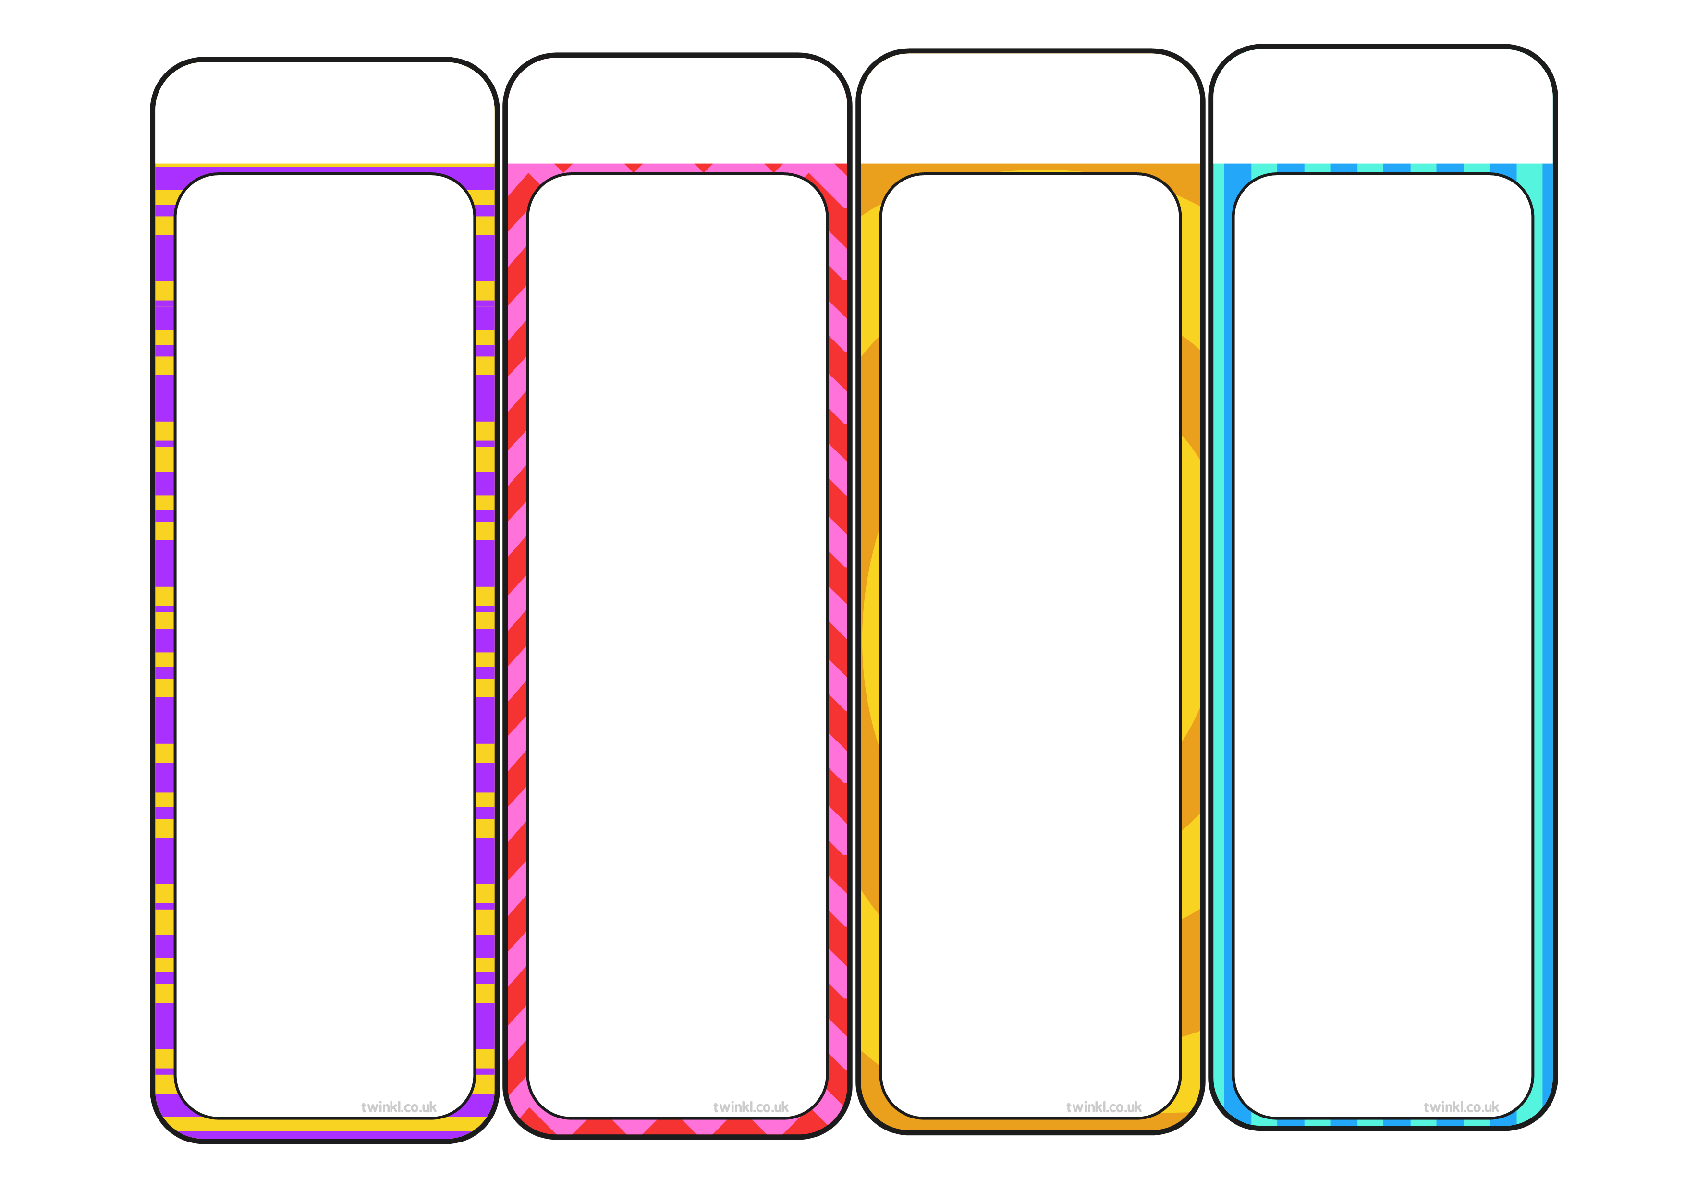

text

text

text

text

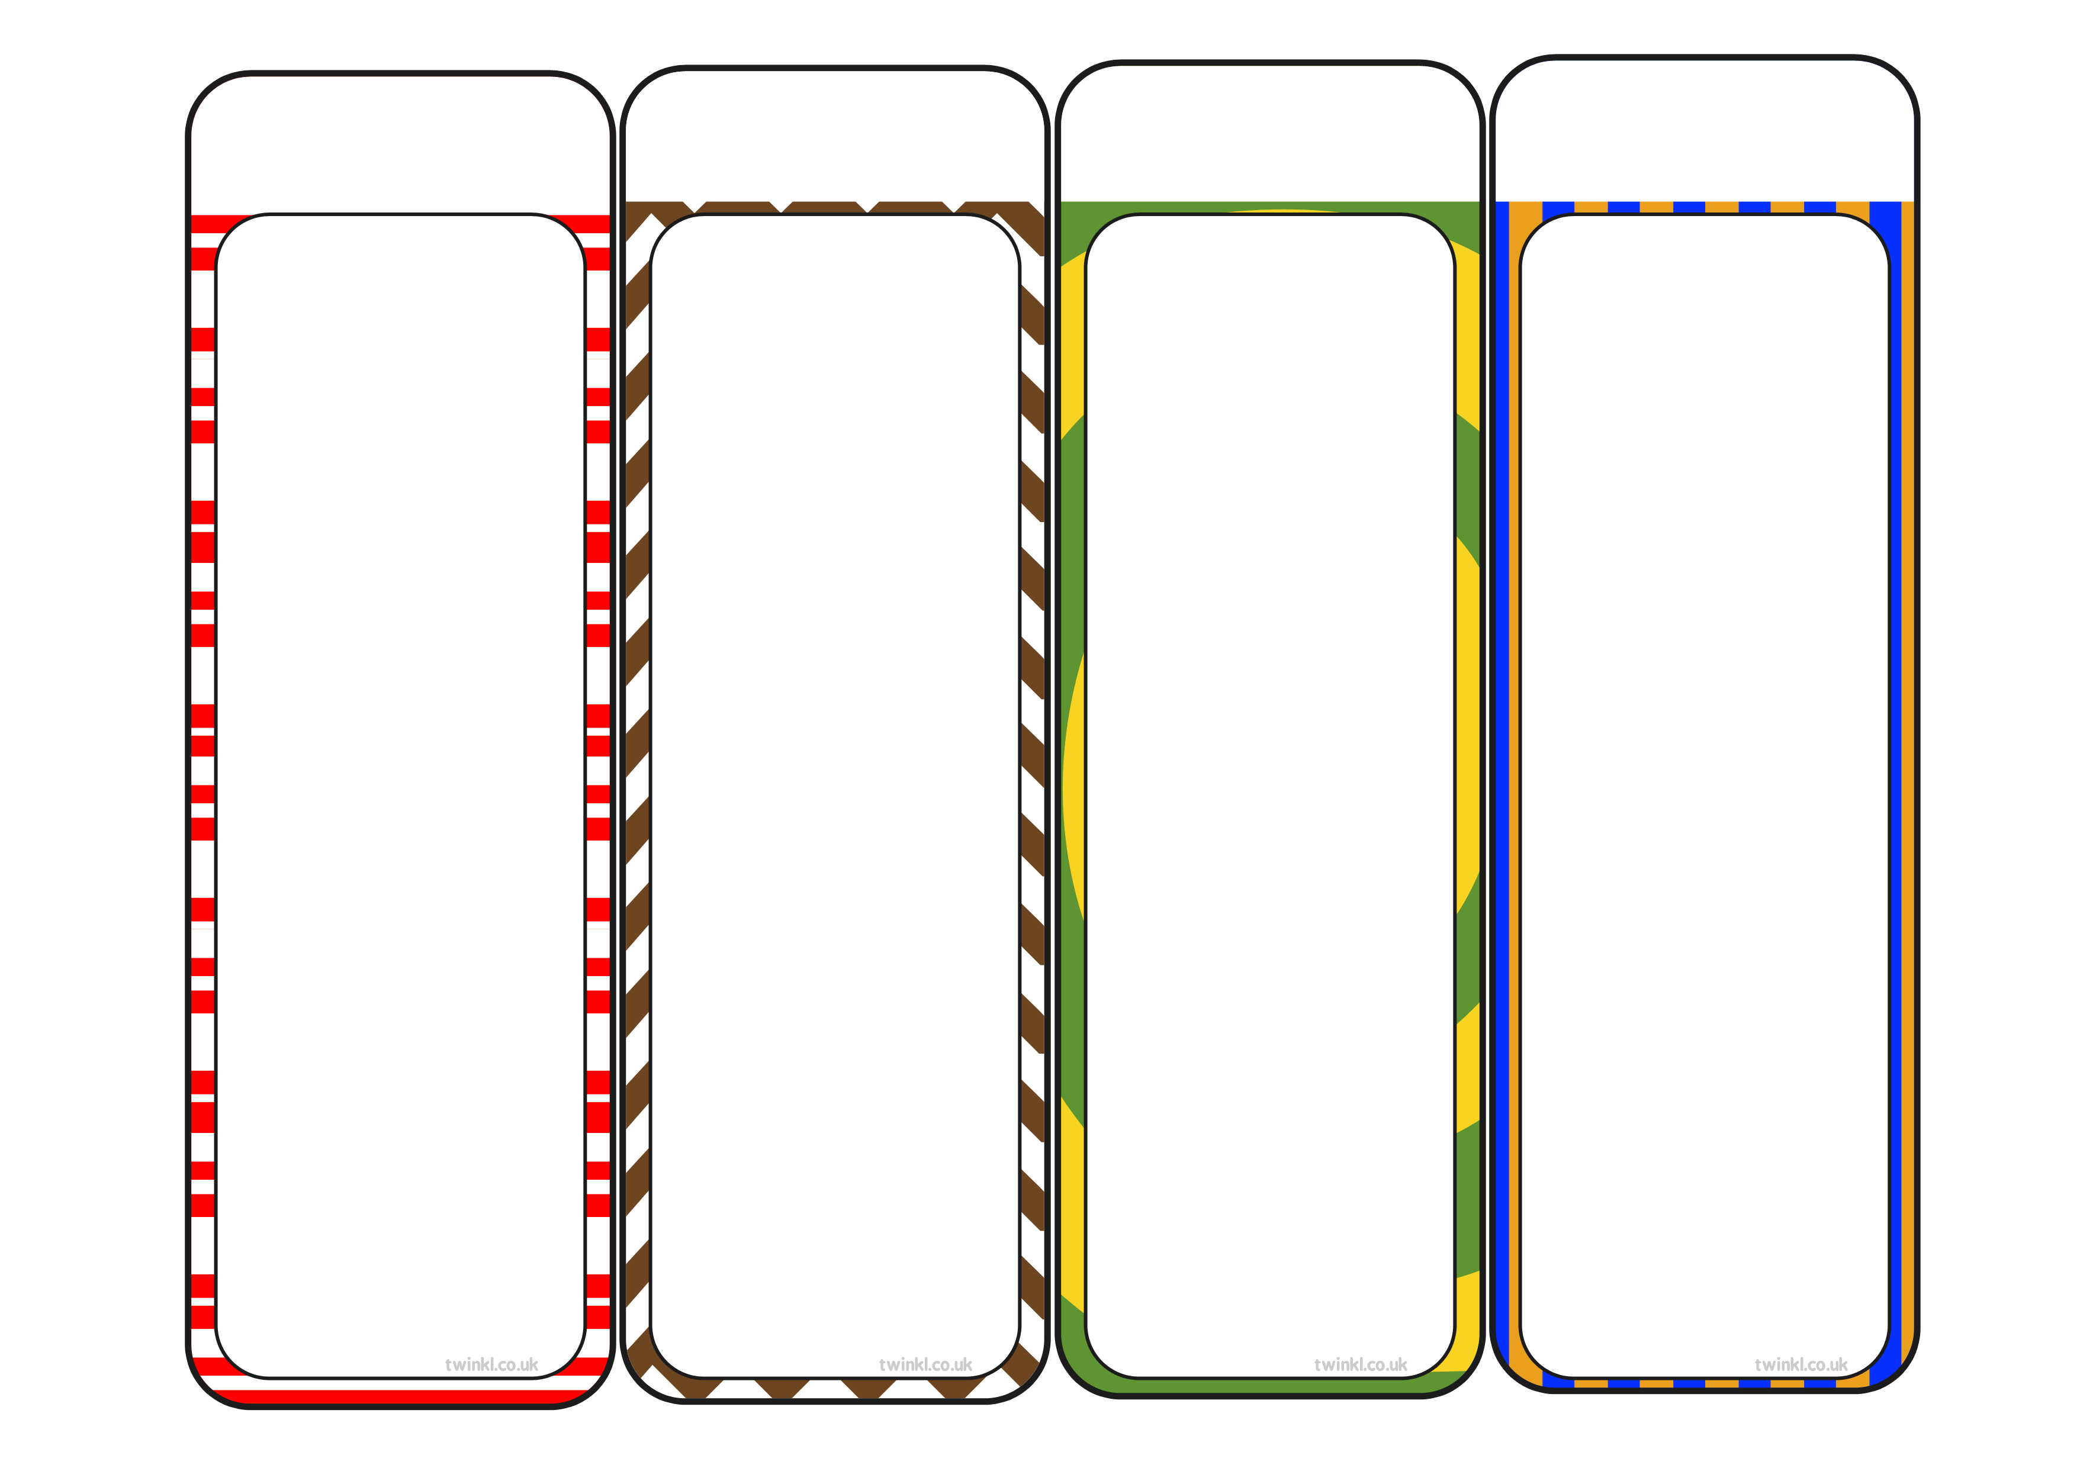

text

text

text

text