

As **Theologians** we will be engaging in the Christian concept, Good News How does the Bible show Jesus living his life as good news? How do you know when you feel better inside or outside?

As **Geographers** we will learn to identify Hot and cold places – North/South Pole (continents).

As **Historians** we will be sequencing events in life and comparing to our friend’s and family’s.

We will enjoy fictional texts based on ‘Lost and Found’ by Oliver Jeffers.

These texts will develop our imaginative and descriptive writing:

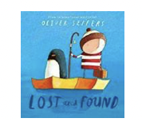 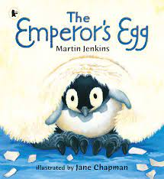 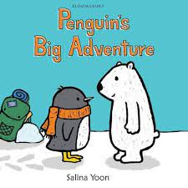 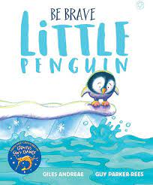 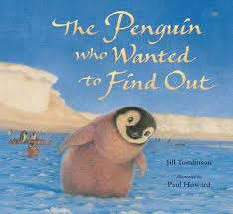

As **Computer Technologists** we will be using Purple Mash to learn about **‘Online Safety’.**

As a **Sports person** we will be developing our **dodging** techniques and applying these into games. Also we will be learning about **health and well-being** to incorporate learning about balance, coordination and agility.

Friendship

– Lost & Found

Hedgehogs’ Class

Autumn One 2025

As **Artists** we will explore the concept of **light and dark**, and use **tones** to **create a storm scene** similar to the one shown in the book.

**Fantastic finish**

We will complete our study theme by having a penguin party.

As **Mathematicians** we will be learning about:

* Place Value
* Addition & Subtraction

As **Musicians** we will explore rhythmic patterns before going on to explore music linking to the animals in our study theme.

**For our RSHE:**

**British Values: Individual Liberty** Articles: 7, 12, 13, 15

**Heartsmart** – Get Heartsmart! & Don’t Forget to Let Love In!

**No Outsiders** enhanced with **P4C**

### Super Starter

We will start our study theme by going on a hunt around school. Who knows what we will find, will it be linked to our new story? A story about a penguin and friendship…

As **Scientists** we will be learning about Animals including humans especially thinking about what we need to survive (in hot and cold places).