Homework tasks
The homework tasks for this half term are based around our topic of ‘Marvellous Me’. The activities below are provided for your child to choose at least one that supports the learning that we have been covering in school. Please bring the completed tasks into school on Monday 20th October 2025. Where we will showcase everyone’s wonderful work. Have fun!
Challenge One  Take a family photo then see if you can draw a copy of the  photo of your family. Bring  them both into school to  share |  | 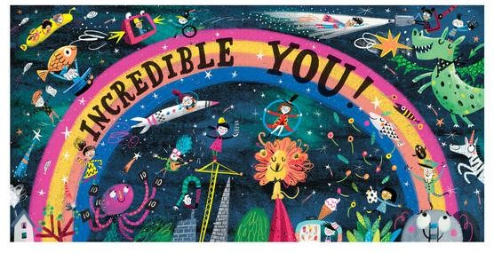 | Challenge six  Can you measure everyone in your family and see who is the tallest/shortest? Take some photos to show us.
Challenge Two
Go on an autumn walk and see how many different signs of autumn you can see, hear, smell and collect. Bring your finds into school to share.

Challenge five
Log in to your Purple Mash account and complete the set ‘to do’ task.

 | Challenge Three Practise writing your name and the rest of your family members (mummy, daddy etc). How many can you write? Challenge Four Can you build your house using junk modelling, Lego or building blocks? |  |  | 